STRR DEMONSTRATION REPORT – 1
Seed to Harvest
Details Of Farmer
Name of Farmers | SURENDAR DUBE
Mobile No. | 90607 47737
Village Name | Harnachiti
Block & Tehsil | Tilouthu
District & State | Rohtash

Field And Crop Detail
Total Acreage(acre) | 10 ACRE
Crops Grown | 10 ACRE
Field Location (Easy approach/road side) | ROAD SIDE
Selected - Crop & Variety | PADDY MTU-7029
Trial Plot Area (KATHA) | 24 katha (Including T1+T2)
Seed Rate (kg/acre) | 3 KG/ACRE
Sowing Date | 15.07.2025

Demo Product Name And Dose& Field day detail
Name of Product | SULFINO GOLD
Application Dose (ml/acre) | 1.1 kg
Date/Time of Application | 27.08.2025
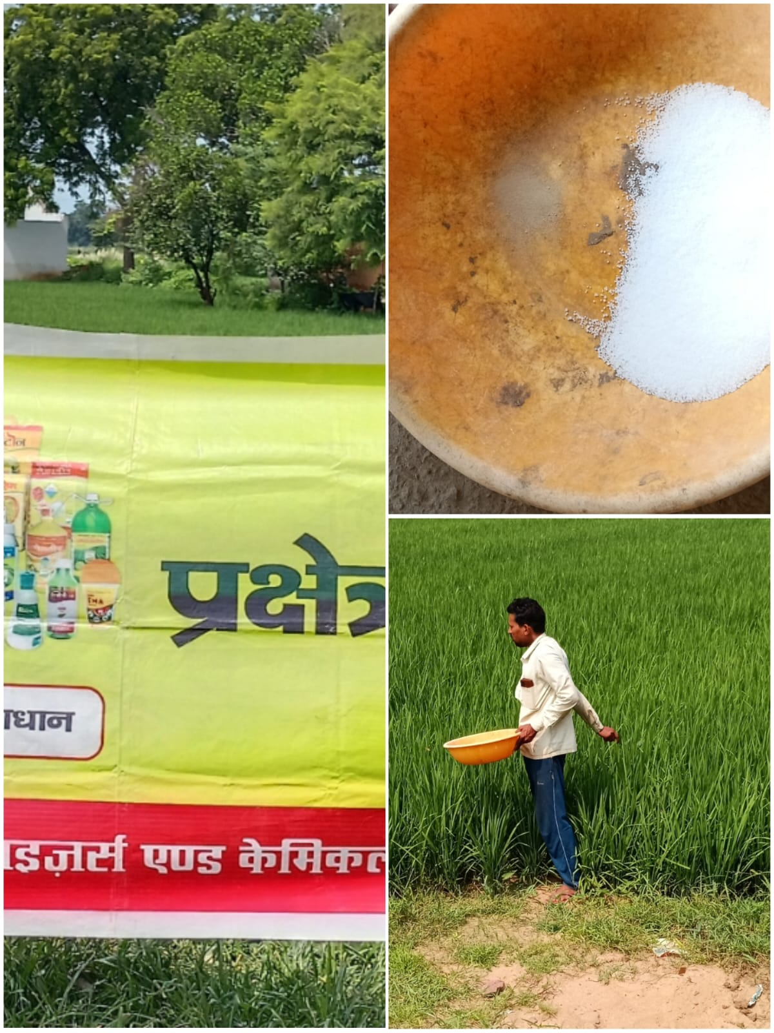
STRR DEMONSTRATION REPORT – 2
Seed to Harvest
Details Of Farmer
Name of Farmers | Rana singh
Mobile No. | 8252154379
Village Name | Kushdihra
Block & Tehsil | Tilouthu
District & State | Rohtash

Field And Crop Detail
Total Acreage(acre) | 30 ACRE
Crops Grown | 30 ACRE
Field Location (Easy approach/road side) | ROAD SIDE
Selected - Crop & Variety | PADDY MTU-7029
Trial Plot Area (KATHA) | 32 katha ( Including T1+T2)
Seed Rate (kg/acre) | 3 KG/ACRE
Sowing Date | 17.07.2025

Demo Product Name And Dose& Field day detail
Name of Product | SULFINO GOLD
Application Dose (ml/acre) | 1.5 kg
Date/Time of Application | 22.08.2025

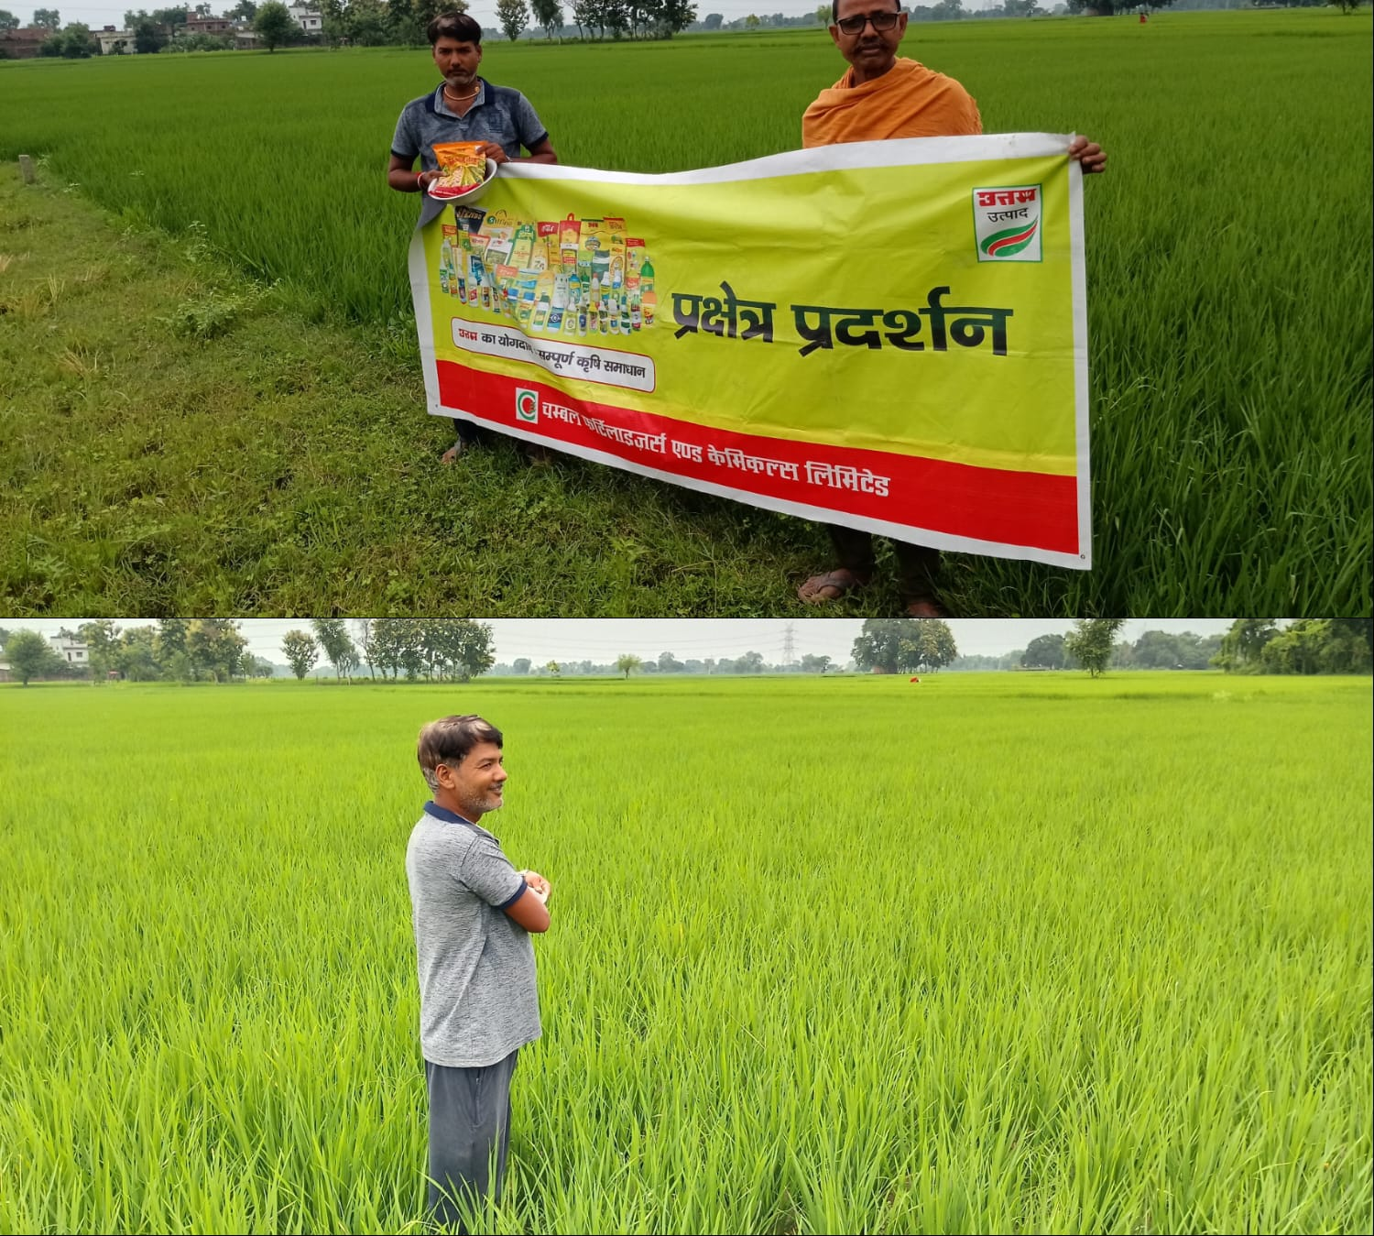

STRR DEMONSTRATION REPORT – 3
Seed to Harvest
Details Of Farmer
Name of Farmers | Umesh chaudhary
Mobile No. | +917079788127
Village Name | Sewahi
Block & Tehsil | Tilouthu
District & State | Rohtash

Field And Crop Detail
Total Acreage(acre) | 10 ACRE
Crops Grown | 10 ACRE
Field Location (Easy approach/road side) | ROAD SIDE
Selected - Crop & Variety | PADDY MTU-7029
Trial Plot Area (KATHA) | 1Bigha(20 katha)( Including T1+T2)
Seed Rate (kg/acre) | 3 KG/ACRE
Sowing Date | 18.07.2025

Demo Product Name And Dose& Field day detail
Name of Product | SULFINO GOLD
Application Dose (ml/acre) | 1 KG
Date/Time of Application | 26.08.2025

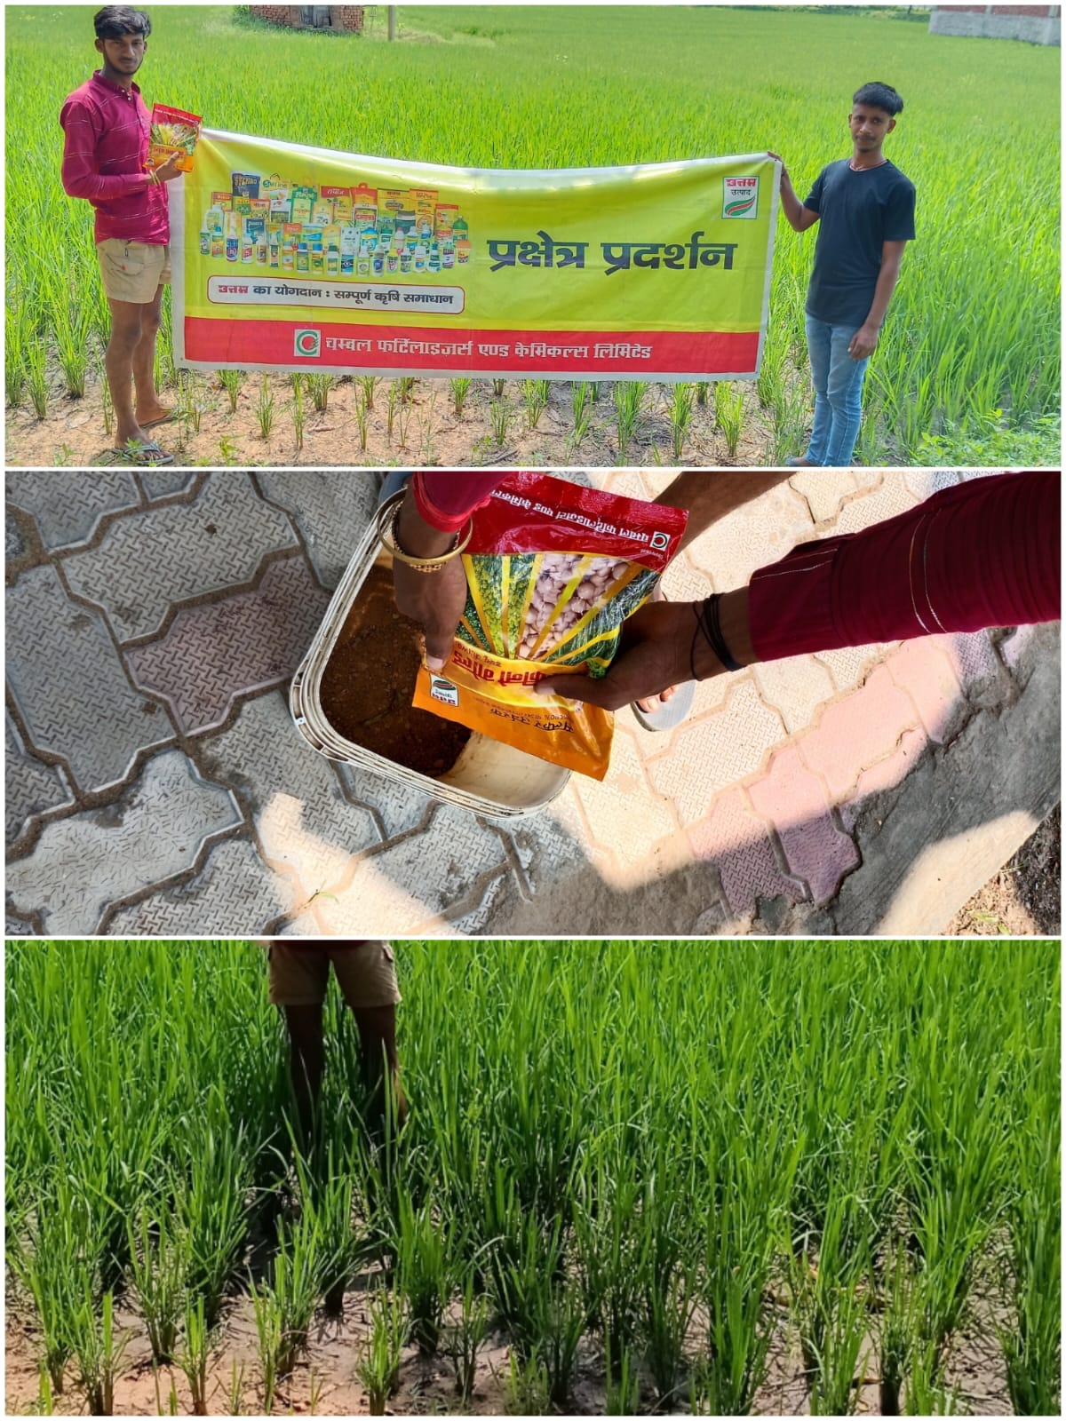

STRR DEMONSTRATION REPORT – 4
Seed to Harvest
Details Of Farmer
Name of Farmers | Ramayan singh
Mobile No. | +919931154501
Village Name | Rendia
Block & Tehsil | chenari
District & State | ROHTASH

Field And Crop Detail
Total Acreage(acre) | 15 ACRE
Crops Grown | 15 ACRE
Field Location (Easy approach/road side) | ROAD SIDE
Selected - Crop & Variety | PADDY MTU-7029
Trial Plot Area (KATHA) | 32 KATHA (INCULDING T1+ T2)
Seed Rate (kg/acre) | 3 KG/ACRE
Sowing Date | 21.07.2025

Demo Product Name And Dose& Field day detail
Name of Product | SULFINO GOLD
Application Dose (ml/acre) | 1.5 KG
Date/Time of Application | 28.08.2025

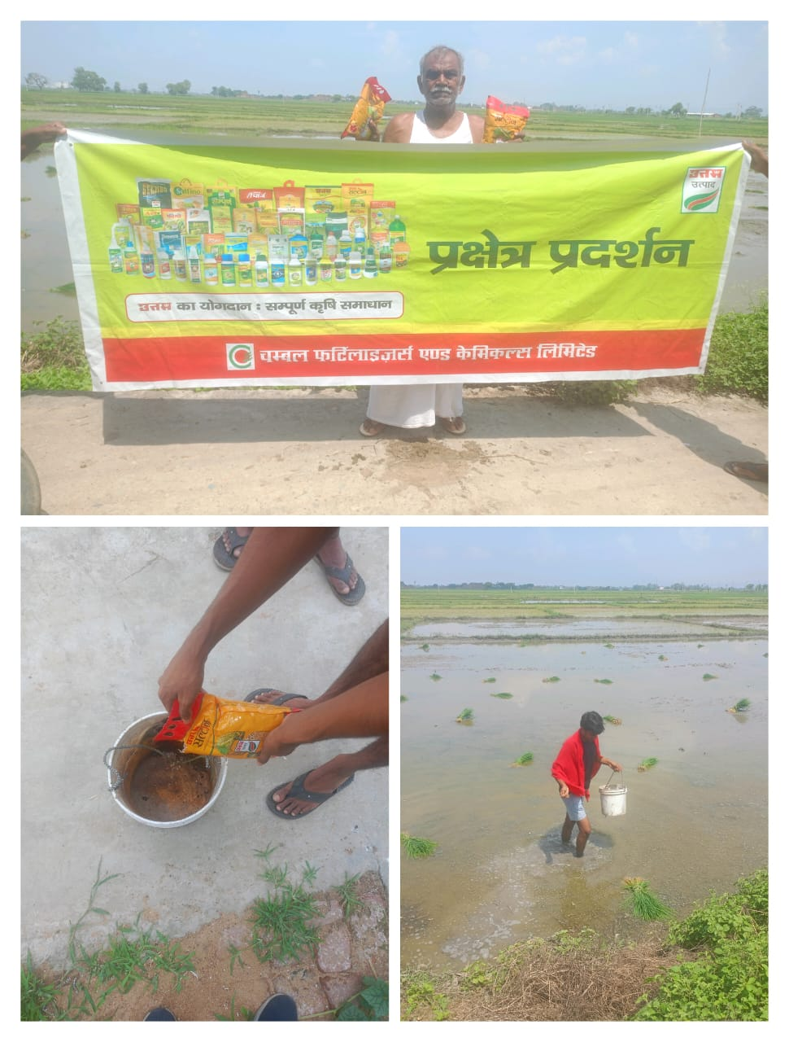

STRR DEMONSTRATION REPORT – 5
Seed to Harvest
Details Of Farmer
Name of Farmers | Chandeshwar tiwari
Mobile No. | +919523804892
Village Name | Tenduni
Block & Tehsil | chenari
District & State | ROHTASH

Field And Crop Detail
Total Acreage(acre) | 15 ACRE
Crops Grown | 15 ACRE
Field Location (Easy approach/road side) | EASY APPROCH
Selected - Crop & Variety | PADDY MTU-7029
Trial Plot Area (KATHA) | 32 KATHA (INCULDING T1+ T2)
Seed Rate (kg/acre) | 03 KG/ACRE
Sowing Date | 21.07.2025

Demo Product Name And Dose& Field day detail
Name of Product | SULFINO GOLD
Application Dose (ml/acre) | 1.5 kg
Date/Time of Application | 30.08.2025

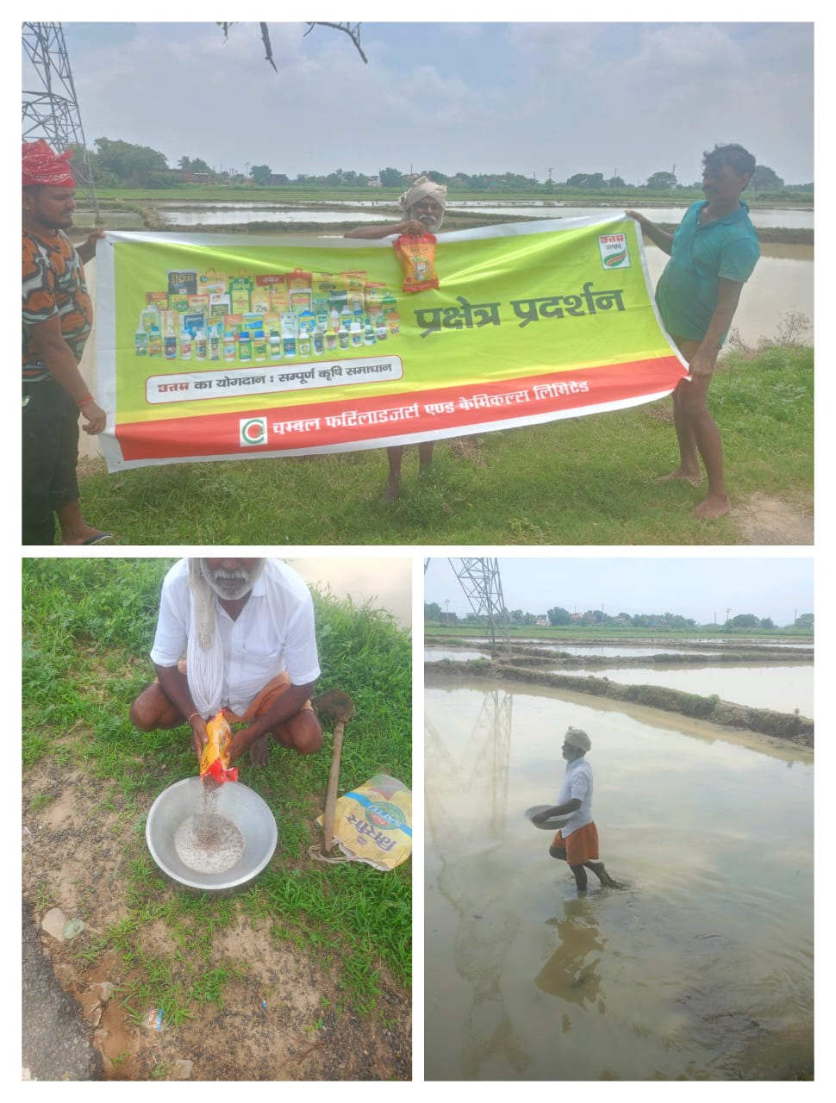

STRR DEMONSTRATION REPORT – 6
Seed to Harvest
Details Of Farmer
Name of Farmers | Vijay Pal
Mobile No. | +919006569604
Village Name | Nawadih
Block & Tehsil | Tilouthu
District & State | ROHTASH

Field And Crop Detail
Total Acreage(acre) | 25 ACRE
Crops Grown | 25 ACRE
Field Location (Easy approach/road side) | ROAD SIDE
Selected - Crop & Variety | PADDY MTU-7029
Trial Plot Area (KATHA) | 32 KATHA (INCULDING T1+ T2)
Seed Rate (kg/acre) | 3 KG/ACRE
Sowing Date | 19.07.2025

Demo Product Name And Dose& Field day detail
Name of Product | SULFINO GOLD
Application Dose (ml/acre) | 1.5 kg
Date/Time of Application | 24.08.2025

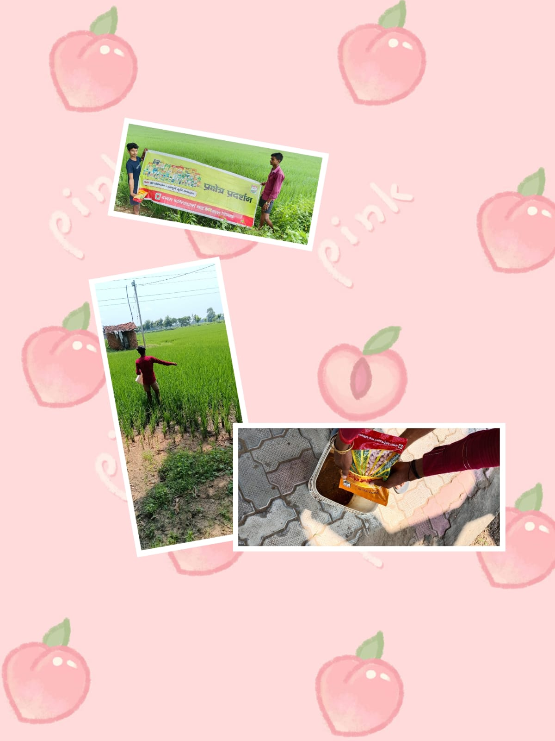
STRR DEMONSTRATION REPORT – 7
Seed to Harvest
Details Of Farmer
Name of Farmers | Madan Prasad
Mobile No. | +917255868062
Village Name | Shahpur
Block & Tehsil | chenari
District & State | ROHTASH

Field And Crop Detail
Total Acreage(acre) | 20 ACRE
Crops Grown | 20 ACRE
Field Location (Easy approach/road side) | EASY APPROACH
Selected - Crop & Variety | PADDY MTU-7029
Trial Plot Area (KATHA) | 32 KATHA (INCULDING T1+ T2)
Seed Rate (kg/acre) | 03 KG/ACRE
Sowing Date | 21.07.2025

Demo Product Name And Dose& Field day detail
Name of Product | SULFINO GOLD
Application Dose (ml/acre) | 1.5 kg
Date/Time of Application | 28.08.2025

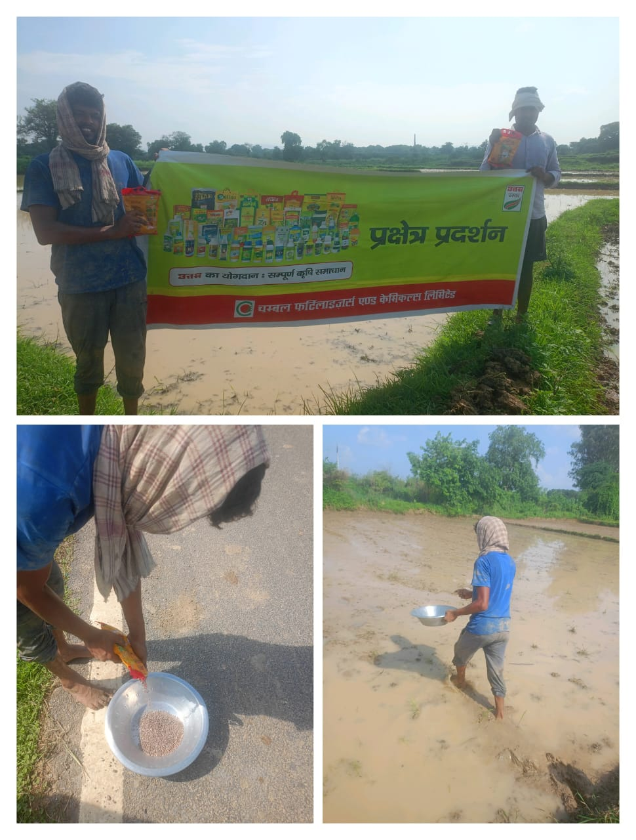

STRR DEMONSTRATION REPORT – 8
Seed to Harvest
Details Of Farmer
Name of Farmers | Satyendra Singh
Mobile No. | +919229927626
Village Name | Chanka
Block & Tehsil | Nokha
District & State | ROHTASH

Field And Crop Detail
Total Acreage(acre) | 08 ACRE
Crops Grown | 08 ACRE
Field Location (Easy approach/road side) | ROAD SIDE
Selected - Crop & Variety | PADDY MTU-7029
Trial Plot Area (KATHA) | 20 KATHA (INCULDING T1+ T2)
Seed Rate (kg/acre) | 03 KG/ACRE
Sowing Date | 25.07.2025

Demo Product Name And Dose& Field day detail
Name of Product | SULFINO GOLD
Application Dose (ml/acre) | 1 KG
Date/Time of Application | 27.08.2025

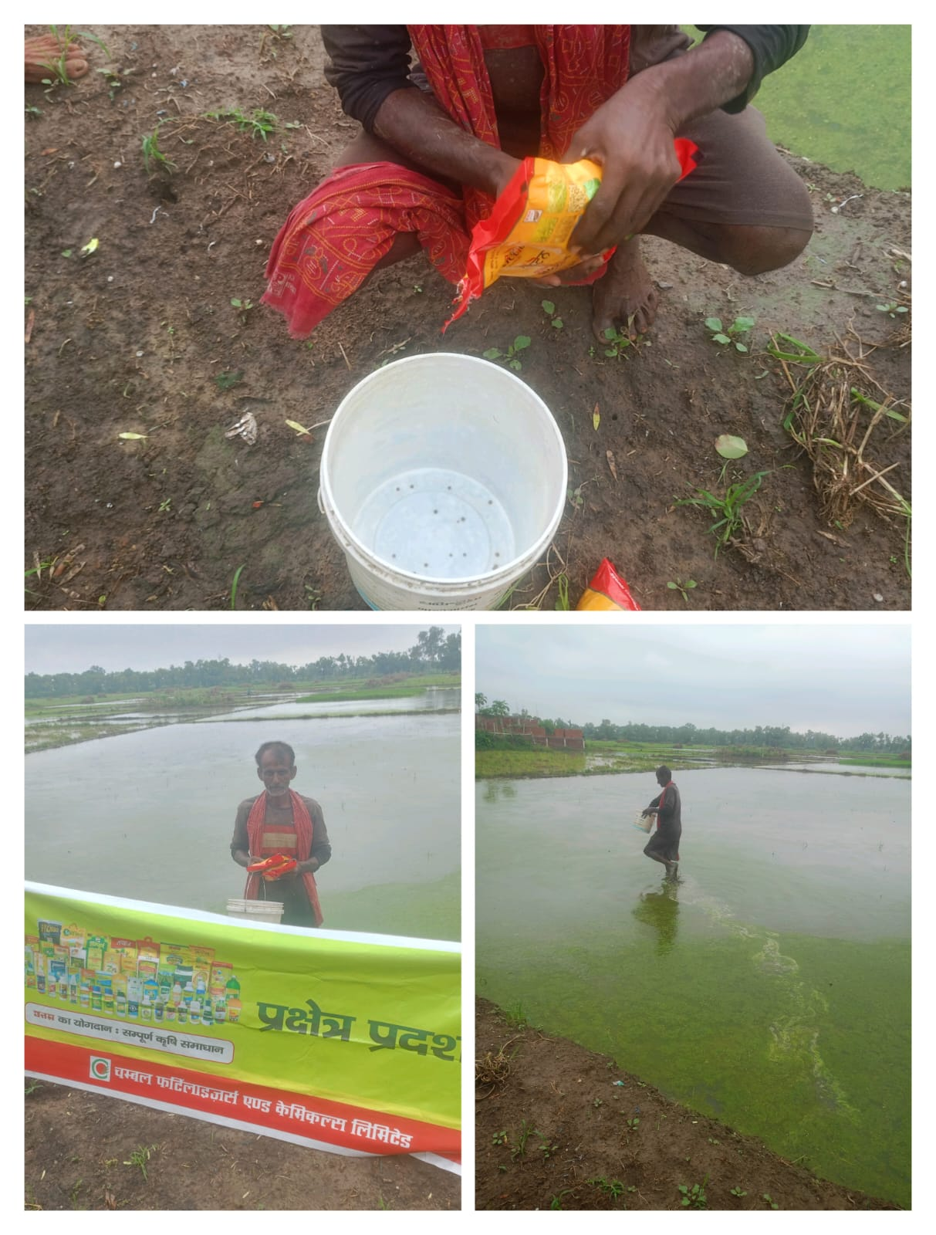

STRR DEMONSTRATION REPORT – 9
Seed to Harvest
Details Of Farmer
Name of Farmers | Sonu Singh
Mobile No. | +919525190393
Village Name | Huruka
Block & Tehsil | Tilouthu
District & State | ROHTASH

Field And Crop Detail
Total Acreage(acre) | 05 ACRE
Crops Grown | 05 ACRE
Field Location (Easy approach/road side) | EASY APPROCH
Selected - Crop & Variety | PADDY MTU-7029
Trial Plot Area (KATHA) | 32 KATHA (INCULDING T1+ T2)
Seed Rate (kg/acre) | 3 KG/ACRE
Sowing Date | 26.07.2025

Demo Product Name And Dose& Field day detail
Name of Product | SULFINO GOLD
Application Dose (ml/acre) | 1.5 KG
Date/Time of Application | 24.08.2025

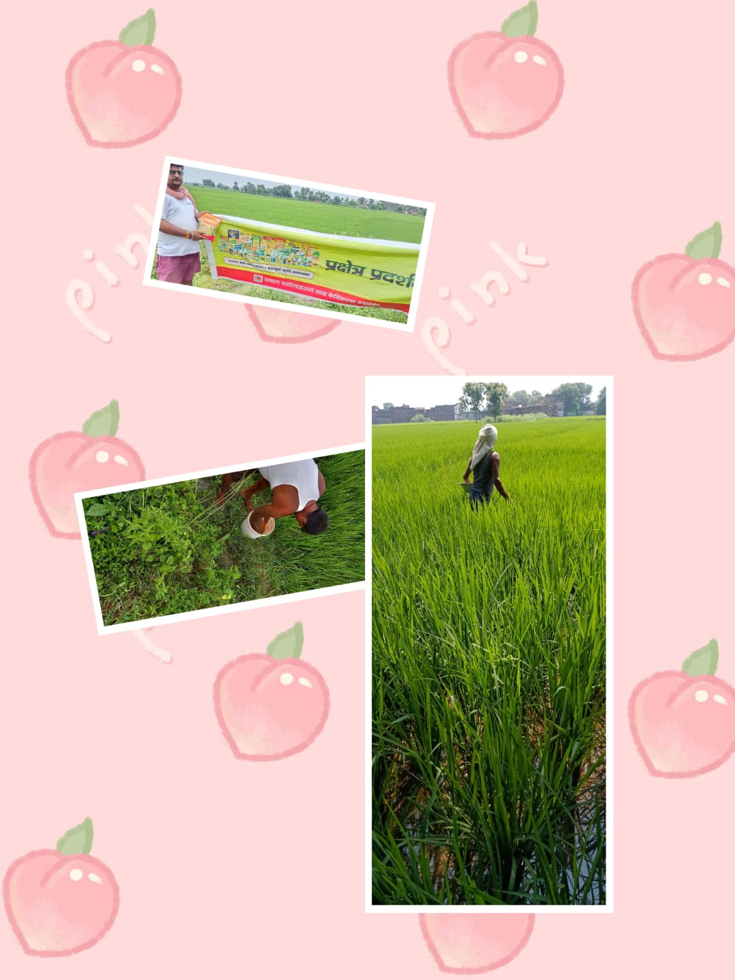

STRR DEMONSTRATION REPORT – 10
Seed to Harvest
Details Of Farmer
Name of Farmers | Madan Yadav
Mobile No. | 7739142235
Village Name | Baradih
Block & Tehsil | Tilouthu
District & State | ROHTASH

Field And Crop Detail
Total Acreage(acre) | 8 ACRE
Crops Grown | 8 ACRE
Field Location (Easy approach/road side) | EASY APPROCH
Selected - Crop & Variety | PADDY MTU-7029
Trial Plot Area (KATHA) | 32 KATHA (INCULDING T1+ T2)
Seed Rate (kg/acre) | 3 KG/ACRE
Sowing Date | 20.08.2025

Demo Product Name And Dose& Field day detail
Name of Product | SULFINO GOLD
Application Dose (ml/acre) | 1.5 KG
Date/Time of Application | 05.07.2025
